1.

Alumno(
num_matricula INT primary key not null,
fecha_nac DATE,
telefono String,
nombre String,
apellidos String
);

Curso_escolar(
id INT primary key not null,
año_ini DATE,
año_fin DATE
);

profesor(
Id INT primary key not null,
nombre String,
apellidos String,
telefono String,
especialidad String
)

asignatura(
Código INT primary key not null,
id_profesor INT (FK)
nombre String
num_horas INT
)

se matricula(
num_matricula (FK) INT primary key not null,
id (FK) INT primary key not null,
Código (FK) INT primary key not null,
)

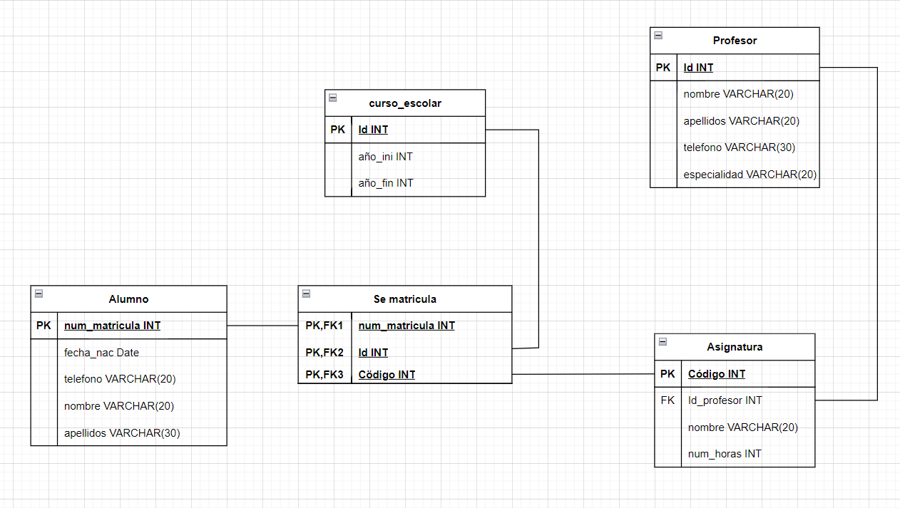
CREATE TABLE IF NOT EXISTS Alumno(
num_matricula INT primary key not null,
fecha_nac DATE,
telefono VARCHAR(20),
nombre VARCHAR(20),
apellidos VARCHAR(30)
);
CREATE TABLE IF NOT EXISTS Curso_escolar(
id_curso INT primary key not null,
año_ini DATE,
año_fin DATE
);
CREATE TABLE IF NOT EXISTS profesor(
ID_PROFESOR INT primary key not null,
nombre VARCHAR(20),
apellidos VARCHAR(30),
telefono VARCHAR(20),
especialidad VARCHAR(20)
);

CREATE TABLE IF NOT EXISTS asignatura(
Código INT primary key not null,
id_profesor INT,
nombre VARCHAR(20),
num_horas INT,
INDEX id_profesor (ID_PROFESOR),
CONSTRAINT ProfesorAsignatura
FOREIGN KEY (ID_PROFESOR)
REFERENCES profesor (ID_PROFESOR)
ON UPDATE CASCADE ON DELETE RESTRICT
);
CREATE TABLE IF NOT EXISTS se_matricula(
num_matricula INT not null,
id_curso INT not null,
Código INT not null,
PRIMARY KEY (num_matricula, id_curso, Código),
INDEX num_matricula (num_matricula),
CONSTRAINT AlumnoSeMatricula
FOREIGN KEY (num_matricula)
REFERENCES alumno (num_matricula)
ON UPDATE CASCADE ON DELETE RESTRICT,
INDEX id_curso (id_curso),
CONSTRAINT CursoMatricula
FOREIGN KEY (id_curso)
REFERENCES Curso_escolar (id_curso)
ON UPDATE CASCADE ON DELETE RESTRICT,
INDEX Código (Código),
CONSTRAINT AsignaturaMatricula
FOREIGN KEY (Código)
REFERENCES asignatura (Código)
ON UPDATE CASCADE ON DELETE RESTRICT
)
2.
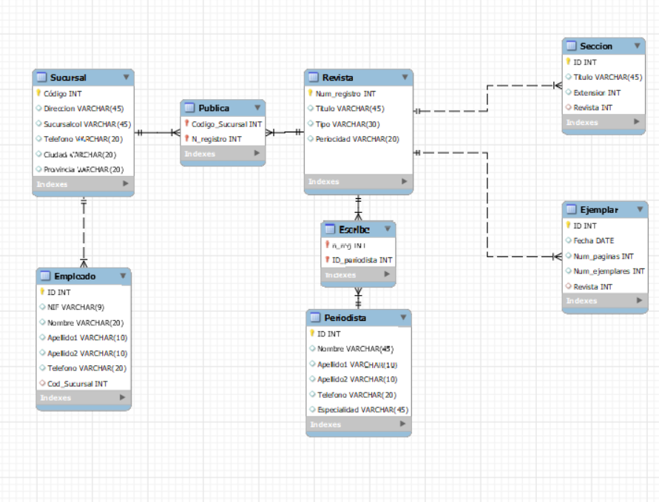
-- MySQL Workbench Forward Engineering

SET @OLD_UNIQUE_CHECKS=@@UNIQUE_CHECKS, UNIQUE_CHECKS=0;
SET @OLD_FOREIGN_KEY_CHECKS=@@FOREIGN_KEY_CHECKS, FOREIGN_KEY_CHECKS=0;
SET @OLD_SQL_MODE=@@SQL_MODE, SQL_MODE='ONLY_FULL_GROUP_BY,STRICT_TRANS_TABLES,NO_ZERO_IN_DATE,NO_ZERO_DATE,ERROR_FOR_DIVISION_BY_ZERO,NO_ENGINE_SUBSTITUTION';

-- -----------------------------------------------------
-- Schema ExamenT4
-- -----------------------------------------------------

-- -----------------------------------------------------
-- Schema ExamenT4
-- -----------------------------------------------------
CREATE SCHEMA IF NOT EXISTS `ExamenT4` DEFAULT CHARACTER SET utf8 ;
USE `ExamenT4` ;

-- -----------------------------------------------------
-- Table `ExamenT4`.`Sucursal`
-- -----------------------------------------------------
CREATE TABLE IF NOT EXISTS `ExamenT4`.`Sucursal` (
`Código` INT NOT NULL,
`Direccion` VARCHAR(45) NULL,
`Sucursalcol` VARCHAR(45) NULL,
`Telefono` VARCHAR(20) NULL,
`Ciudad` VARCHAR(20) NULL,
`Provincia` VARCHAR(20) NULL,
PRIMARY KEY (`Código`))
ENGINE = InnoDB;

-- -----------------------------------------------------
-- Table `ExamenT4`.`Empleado`
-- -----------------------------------------------------
CREATE TABLE IF NOT EXISTS `ExamenT4`.`Empleado` (
`ID` INT NOT NULL,
`NIF` VARCHAR(9) NULL,
`Nombre` VARCHAR(20) NULL,
`Apellido1` VARCHAR(10) NULL,
`Apellido2` VARCHAR(10) NULL,
`Telefono` VARCHAR(20) NULL,
`Cod_Sucursal` INT NULL,
PRIMARY KEY (`ID`),
INDEX `Cod_Sucursal` (`Cod_Sucursal` ASC) VISIBLE,
CONSTRAINT `EmpleadoSucursal`
FOREIGN KEY (`Cod_Sucursal`)
REFERENCES `ExamenT4`.`Sucursal` (`Código`)
ON DELETE RESTRICT
ON UPDATE CASCADE)
ENGINE = InnoDB;

-- -----------------------------------------------------
-- Table `ExamenT4`.`Revista`
-- -----------------------------------------------------
CREATE TABLE IF NOT EXISTS `ExamenT4`.`Revista` (
`Num_registro` INT NOT NULL,
`Titulo` VARCHAR(45) NULL,
`Tipo` VARCHAR(30) NULL,
`Periocidad` VARCHAR(20) NULL,
PRIMARY KEY (`Num_registro`))
ENGINE = InnoDB;

-- -----------------------------------------------------
-- Table `ExamenT4`.`Periodista`
-- -----------------------------------------------------
CREATE TABLE IF NOT EXISTS `ExamenT4`.`Periodista` (
`ID` INT NOT NULL,
`Nombre` VARCHAR(45) NULL,
`Apellido1` VARCHAR(10) NULL,
`Apellido2` VARCHAR(10) NULL,
`Telefono` VARCHAR(20) NULL,
`Especialidad` VARCHAR(45) NULL,
PRIMARY KEY (`ID`))
ENGINE = InnoDB;

-- -----------------------------------------------------
-- Table `ExamenT4`.`Seccion`
-- -----------------------------------------------------
CREATE TABLE IF NOT EXISTS `ExamenT4`.`Seccion` (
`ID` INT NOT NULL,
`Titulo` VARCHAR(45) NULL,
`Extension` INT NULL,
`Revista` INT NULL,
PRIMARY KEY (`ID`),
INDEX `Seccion_Rev` (`Revista` ASC) INVISIBLE,
CONSTRAINT `SeccionRevista`
FOREIGN KEY (`Revista`)
REFERENCES `ExamenT4`.`Revista` (`Num_registro`)
ON DELETE NO ACTION
ON UPDATE NO ACTION)
ENGINE = InnoDB;

-- -----------------------------------------------------
-- Table `ExamenT4`.`Ejemplar`
-- -----------------------------------------------------
CREATE TABLE IF NOT EXISTS `ExamenT4`.`Ejemplar` (
`ID` INT NOT NULL,
`Fecha` DATE NULL,
`Num_paginas` INT NULL,
`Num_ejemplares` INT NULL,
`Revista` INT NULL,
PRIMARY KEY (`ID`),
INDEX `Revista` (`Revista` ASC) VISIBLE,
CONSTRAINT `EjemplarRevista`
FOREIGN KEY (`Revista`)
REFERENCES `ExamenT4`.`Revista` (`Num_registro`)
ON DELETE RESTRICT
ON UPDATE CASCADE)
ENGINE = InnoDB;

-- -----------------------------------------------------
-- Table `ExamenT4`.`Publica`
-- -----------------------------------------------------
CREATE TABLE IF NOT EXISTS `ExamenT4`.`Publica` (
`Codigo_Sucursal` INT NOT NULL,
`N_registro` INT NOT NULL,
PRIMARY KEY (`Codigo_Sucursal`, `N_registro`),
INDEX `codigo_sucursal` (`Codigo_Sucursal` ASC) INVISIBLE,
INDEX `n_registro` (`N_registro` ASC) VISIBLE,
CONSTRAINT `SucursalPublica`
FOREIGN KEY (`Codigo_Sucursal`)
REFERENCES `ExamenT4`.`Sucursal` (`Código`)
ON DELETE RESTRICT
ON UPDATE CASCADE,
CONSTRAINT `PublicaRevista`
FOREIGN KEY (`N_registro`)
REFERENCES `ExamenT4`.`Revista` (`Num_registro`)
ON DELETE RESTRICT
ON UPDATE CASCADE)
ENGINE = InnoDB;

-- -----------------------------------------------------
-- Table `ExamenT4`.`Escribe`
-- -----------------------------------------------------
CREATE TABLE IF NOT EXISTS `ExamenT4`.`Escribe` (
`n_reg` INT NOT NULL,
`ID_periodista` INT NOT NULL,
PRIMARY KEY (`n_reg`, `ID_periodista`),
INDEX `n_reg` (`n_reg` ASC) VISIBLE,
INDEX `ID_periodista` (`ID_periodista` ASC) VISIBLE,
CONSTRAINT `n_reg`
FOREIGN KEY (`n_reg`)
REFERENCES `ExamenT4`.`Revista` (`Num_registro`)
ON DELETE RESTRICT
ON UPDATE CASCADE,
CONSTRAINT `ID_periodista`
FOREIGN KEY (`ID_periodista`)
REFERENCES `ExamenT4`.`Periodista` (`ID`)
ON DELETE RESTRICT
ON UPDATE CASCADE)
ENGINE = InnoDB;

SET SQL_MODE=@OLD_SQL_MODE;
SET FOREIGN_KEY_CHECKS=@OLD_FOREIGN_KEY_CHECKS;
SET UNIQUE_CHECKS=@OLD_UNIQUE_CHECKS;

